ELEC2217 - Team B - 2nd Review Report 24/2/2023
Abi Brett, Giulio Girelli, Thomas Short, Muhammad Yusri, Jerry Wang, Syazwan Zulkepli

1. Introduction
In this report, we present our smart-meter group project, which aims to design a system that maximizes power usage efficiency and supports renewable energy sources using algorithm decision making. We describe the housing and PSU design, simulation results, interface and software development, and challenges of our project. We also discuss the implications, limitations, and future directions of our work. This report demonstrates our achievements and learning outcomes from this project.

2. Project Progress
The contributions by the members have been fairly balanced with everyone having their own major roles and contributions on each crucial part of the project. For the group deliveries we have managed to collaborate effectively with each other and carry out all the tasks as a performing team. For Housing, Giulio has contributed the most as he has the most experience with CAD software. For PSU design and testing, the work has been mostly collaborative between Jerry and Abi. Interface design and testing has been completed by Tom and Abi. Syazwan has been responsible for the software part of the project, as he is the most skilled in terms of coding. Muhammad has checked the quality and the integration of each part, and has taken over the LabView simulations of our device. Despite the challenging deliverables, we have successfully followed our plans and met our deadlines. We have taken care of avoiding to rush through our work and leave it for the last-minute submission. Figure 1 shows the front view of our device.
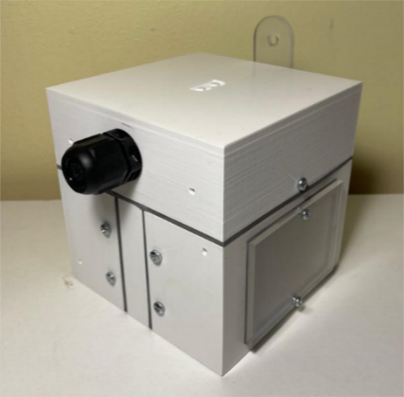Figure 1: front view of box
3. Box design
We have made the box 105x105x105 mm to allow space for the head of the screws and meet the size requirement. To minimize the junctions that could cause internal water leakage, we have chosen to divide the box in 4 pieces: a top part and 3 parts at the bottom. The top part is mounted with a screw to the right and the left parts, as it can be seen in Figure 2.a. The latter are kept tight together by the middle piece, which shares 4 bolts with both, as shown in Figure 2.b. The box can be easily and quickly opened by unscrewing the two screws that keep the top attached to the bottom and splitting them apart. The walls of the box have been made 4mm wide, which allow a good strength and implementations of other features.
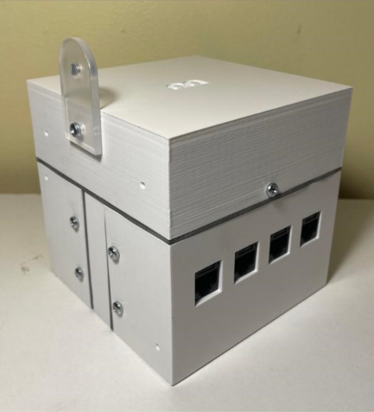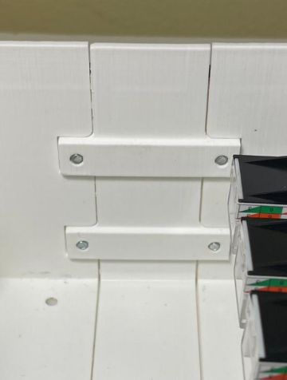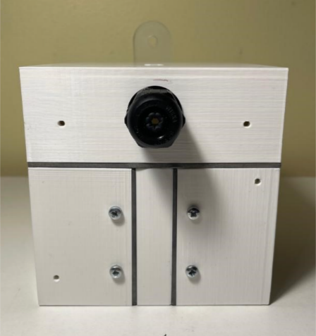
Figure 2: (a) back view of box, (b) joint of parts, (c) front face of box
We have incorporated in-out mountings, which turned out to be a more effective in terms of compression of the parts together, compared to other solution that we tested, which had screws on the outside. M3 bolts are used for the Il-Matto, the mounting lug and the mounts in between parts, as they need to withstand greater strain; the rest has been suited for M2.5 bolts. To enhance water resistance, we have sectioned the extremities of the parts, such that they can fit into each other and break the straight path into the box for water. We have also left some space on the external joints to place and compress rubber gasket, counteracting internal water leakage, as shown in Figure 2.c.
Figure 3: (a) inside of box, (b) right face of box, (c) left face of box
The four RJ45 connectors have been placed on the left side, Figure 3.c. Our design includes clipping features on the internal wall, Figure 3.a, so that the connectors are well fixed in place. The display has been located on the right side, Figure 3.b. It is fixed from the inside with 4 brackets, and it has been covered from the outside with an acrylic sheet. Next to the display, we have fitted the green LED. Figure 3.a also depicts the bottom part, which is where the Il-Matto has been screwed up. In this way, it could be easily wired to the other parts of the device. The top piece is where the PSU has been segregated and where the gland for the mains cable has been fitted, Figure 2.c. A printed plastic floor has been used to divide the top section to the rest of the box. The mounting lug has been made of acrylic and externally fixed to the top part. The interface circuitry has taken the rest of the space left inside the box. The housing was tested several times under the shower to assess its water-resistive capabilities. The results were very positive, as almost no water entered the box.
4. Power Supply Unit
We have successfully integrated a capacitor pump PSU for the smart-meter design. At first, we used a half-wave rectifier design, Figure 4, which was relatively less efficient as the neutral wire was grounded. Consequently, the negative voltage was zeroed by the ground and half of the input power was lost. This resulted in the output being low and less desirable for the smart-meter’s requirements. Hence, we have decided to implement the full-wave rectifier instead, to obtain higher output power and improve efficiency, Figure 5.
Figure 4: The first PSU design with half-wave rectifier
The 1.5u capacitance capacitor and R3 act as the ‘pump’ and are responsible for charging and discharging voltage directly from the main power. Figure 6.a shows the voltage ‘pump’ action of the C2 capacitor. For safety reasons, C2 has been chosen X2 rated. R3 acts as the bleeding resistor of the C2 capacitor to ensure safety, such that C2 is discharged to less than 2V after being disconnected from the main in less than 2s.
The implementation of the full-wave rectifier consists of four 1N4148 diodes. The full-wave rectifier converts the alternating current into direct convergent, which is desirable for both interface circuitry and powering the Il-Matto. Figure 6.b shows the waveform after the full-wave rectifier, as the alternating current became pulsating DC current all in the positive y-axis.
Figure 5: The final PSU design with full-wave rectifier
Figure 6: (a) The Voltage Waveform of C2 capacitor, (b) Voltage after the rectifier
In order to smooth out the pulsating DC voltage produced by the full-wave rectifier, we have used a 6800u smoothing capacitor to smooth out the output of the PSU. As this capacitor charges and discharges at high frequency, the sinusoidal wave becomes a smooth curve reaching steady-state around 4.5s.
We have implemented a 12V zener diode to limit the voltage output of the PSU, since the interface circuit required at least 10V. A 1K ohm resistor R4 has been placed in series with the zener diode in order to prevent too much current going across it.
At the load we have used a potential divider where both resistors are used as outputs, such that maximum efficiency is maintained. R1 is the output for the interface circuit, and when it is connected it gives out 12.41V to the interface op-amp. R2 connects to the Il-Matto and outputs 3.3V to the voltage regulator. Output waveforms are shown in Figure 7.
Figure 7: PSU schematic output waveform before connects to the smart-meter
After testing, we found out that resistor is not suitable for distributing voltage for microcontrollers, since the current draw of microcontroller changes constantly and the resistor cannot have a steady supply of voltage and current. Therefore, we have added an external voltage regulator outside the PSU, as shown in Figure 8. After careful consideration, we have decided to use the circuit for the LM3090 voltage regulator with an output of 3.3V.
Figure 8: (a)The voltage regulator circuit, (b)The voltage regulator build on stripboard.
The PSU successfully supplies 3.2V to the voltage regulator, which in turn successfully powers Il-Matto with 3.1V. The output that connects to the interface circuitry produces 12.4V. The current draw of the Il-Matto and the interface circuitry is about 75mA, which results in a total power output of 1.15W. The power consumption is 1.5W when the smart-meter is in operation, resulting in an efficiency of 0.9/1.5 = 60%. This value of efficiency is acceptable and has been expected by the capacitor power supply unit design.

5. Software algorithm
Our project’s software is designed as best as possible to assure a smooth running of our smart-meter device. The microcontroller uses an analogue-to-digital converter to measure the busbar voltage and current, wind capacity, and solar capacity (ADC). Based on the matching load calls, the microcontroller examines the measurements to decide which load switch should be turned on and off. The algorithm also assesses how much current is required from main if renewable energy is inadequate to fully charge the battery and power the load.
The software design is written in C, which was chosen for the design’s adaptability, portability, and embedded system effectiveness. Analogue to Digital conversion (ADC), Pulse Width Modulation (PWM), display, and algorithm are the system’s four core parts.
The busbar’s voltage and current, as well as the amounts of wind and solar energy, are all measured by the ADC feature of the Atmega644p microcontroller. To calculate and control power, the module converts the analogue signals to digital signals. Traditionally, the busbar voltage and current signals are stabilised using complex circuit interfaces before they can be fed into a microcontroller for further reading. However, in our smart-meter, we have implemented a unique approach where the Il-Matto is used to directly measure the scaled down AC signals without converting it to DC. This is done by measuring the ADC input and comparing the measured values in every instance to find the maximum value. This maximum value is used to find the root mean square of the AC signal. Many advantages of this approach include a more straightforward overall design and a circuit interface with less complexity.
The quantity of power requested from the main supply is decided by the PWM signal. It adjusts the voltage levels to the proper level required to charge the battery and power the load. Figure 9 shows the output of a working PWM at 30% duty cycle as observed from an oscilloscope.
Figure 9: Working PWM output from the smart-meter.
The display module is responsible for providing the user with the real-time status of the system. This involves power consumption, battery status and percentage, and load status. A simple graphic depiction of the power produced by renewable sources is also included. Figure 10 shows the UI of our smart-meter.
Figure 10: The latest display design
Based on the appropriate load calls, the algorithm module determines which load switches to turn on and off. If there is insufficient energy from renewable sources to charge the battery and power the load, it will decide how much power to request from main supply or if there is enough battery percentage to discharge. The algorithm is also designed to maximise the survival rate as much as possible, by deciding which is the best load to turn off in the event of insufficient renewable energy, main supply, and battery to power all loads in demand.

6. Interface Circuitry
Circuit designs for analogue input and output, digital input and output have all been considered and simulated using LTSpice.
The plan for the digital input was to connect directly to the Il-Matto and keep a backup circuit design. For the digital output, a circuit that makes use of a BC547B NPN transistor was built on stripboard. However, once it came to integration, the circuit became redundant as the il-Matto can take the signal directly, consuming less power.
Figure 11: Analogue Input Schematic
For the analogue input, we have used the Il-Matto’s PWM output to create a Digital-to-Analogue-Converter substitute. Figure 11 shows the RC filter going into the input of the TS954IN opamp. However, we encountered issues relating to the cut-off frequency, causing a non-steady output voltage which varied incorrectly with the duty cycle. The TS954IN opamp was chosen as the 14V max supply voltage was high enough to allow for a range of 0-10V. The supply current did not go above 1.1mA for 10V, achieving lower power consumption. After adjusting the parameters of the RC filter we were able to reduce the cut off frequency and subsequently achieve full circuit functionality. After adjustment, the duty cycle variation led the circuit to linearly output a DC voltage between 0v-10.3v. There was a maximum ripple of around 50mV at 50% duty cycle that next time we would reduce with a smoothing capacitor.
Figure 12: Analogue Output Schematic
The 50Hz AC analogue output interface circuitry started as a half wave rectifier circuit which also acts as an inverting amplifier with a gain off less than 1 to scale the signal appropriately. Attenuating the negative voltage component of the AC input is necessary as the ADC of the Il-Matto can only read positive values between 0-Vcc (0-3.3v). During testing the circuit was unreliable, this led to a redesign of our circuit to use a full wave rectifier leading to a resistor and capacitor in parallel, Figure 12. This was chosen over a single diode as it allowed for greater efficiency and the use of a smaller smoothing capacitor. The circuit also can respond faster to changes and has small enough ripple to prevent errors to the Vmax reading on the ADC. The redesign of the analogue output requires no opamp and is more compact. Therefore, the circuits could be placed separately making integration easier. With more time, we could change the PWM quad opamp to a single opamp to minimise loss.
After reviewing the final scenario, the max value of the Analogue DC output was within the Il-Matto’s reading range, hence it did not need any circuitry.
Through testing and consideration of the final scenario we have cut the interface circuitry down to just the two circuits shown in the figures above. Whilst it was not part of the task it could be argued that these decisions would both reduce manufacturing costs and increase manufacturing efficiency.

7. Integration
Our smart-meter has experienced a step-by-step integration, where simulating and testing have been very crucial to ensure the best quality. In the integrating stage of our device, we have made sure that our smart-meter is first of all safe and avoids any potential shock hazard. The internal sections have been kept as neat as possible by shorting wires and smart positioning. The wires connecting the PSU to Il-Matto have been made much longer, to make sure that when the box is opened the connections do not break or come off. Our layout inside the box also ensures that none of the components can touch each other and cause some unintended short circuits that could affect the operation of the device.
8. Budget
From the £40 budget allowed, we spent £13.55 to buy components that were needed to integrate in our PSU. We bought 12V zener diodes, the 6800uF capacitor, and the 5.6uF X2-rated capacitor.
9. Conclusion
Thanks to great effort from all members of the team, we managed to complete the project and submit our fully functional smart-meter. Teamwork played a key role in our design and allowed us to be on time for all the deadlines spread across the 7 weeks. Despite the challenges and the time constraints, each component of our smart-meter was thoroughly designed, simulated and tested.
Over the course of the project, we tried a number of solutions both for the PSU and the interface circuitry. The first solutions unfortunately were not as efficient as we expected, and we spent a lot of time trying to improve them, by researching and simulating new solutions. Although, the tests on stripboard were often far from the simulation expectations, we finally managed to produce circuits that were functionally better. When it came to the first review, our PSU managed to meet the requirements, but it consumed a bit too much power. In the end, the PSU was successfully powering the Il-Matto and producing a sufficiently high reference voltage for the interface, while the interface was carrying out all the designed tasks.
The box was successfully designed and improved several times since the start of the project, by doing several test-prints and correcting small details. At the water-test during the second review, the box did not perform as good as expected, as 2ml of water leaked in. We identified that the acrylic sheet covering the display was the most sensitive part of the box, which may have caused those small water drafts into the box. We realized that we could have used four bolts instead of two to fix the acrylic sheet to the box, which could have made the component tighter to the wall and could have avoided water leakage.
The software experienced a steady progress week by week for both the control of the display and the control of the signals. The few issues on blinking and calculations were solved quite quickly. The algorithm was designed to prioritize Load 1 above the others and consider Load 3 as least important. The control flow was based on the renewables availability and on the battery level. Our design was aimed to save as many people as possible from the scenario and minimize mains usage.
In conclusion, we managed to finalise the design and the assembly of the device, which met all the requirements. At the final review we encountered some issues with the PSU and the LabView software, which did not allow us to test our device as much as we wanted. The final output produced a fairly good score, but we regret that we could not submit a better version of it. In our last submission, both our mains usage and our battery ratio usage were too high. These issues could have been caused by either the algorithm being designed not well enough or by the interface that produced some wrong signals. If more time were allowed for the project, we could have spent more time testing the device fully integrated and ensured a better performance.

